CSA1519-CLOUD COMPUTING FOR BIG DATA ANALYTICS
LAB EXPERIMENTS
1. Create a simple cloud software application and provide it as a service using any Cloud Service Provider to demonstrate Software as a Service (SaaS).
AIM
To design and deploy a cloud-based Hospital Management System using Zoho Creator and provide it as a Software as a Service (SaaS), enabling users to access hospital services such as patient registration, appointment scheduling, and health record management through the internet.
MATERIALS REQUIRED
🔹 Hardware Requirements
- Computer / Laptop
- Internet connection
🔹 Software Requirements
- Web Browser (Google Chrome / Edge)
- Zoho Account
- Zoho Creator (Cloud Platform)
🔹 Cloud Service Provider
- Zoho Cloud

PROCEDURE
Step 1: Create Zoho Account
- Open a web browser.
- Go to the Zoho website.
- Sign up or log in using an existing Zoho account.
Step 2: Access Zoho Creator
- Open Zoho Creator from the Zoho dashboard.
- Click Create Application.
- Select Blank Application.
- Enter application name as Hospital Management System.
Step 3: Create Patient Registration Form
- Click Create Form.
- Add the following fields:
  - Patient Name
  - Age
  - Gender
  - Contact Number
  - Address
  - Health Problem
  - Date of Visit
- Save the form.

Step 4: Create Doctor Details Form
- Create another form named Doctor Details.
- Add fields:
  - Doctor Name
  - Specialization
  - Contact Number
  - Available Time
Step 5: Create Appointment Form
- Create a form named Appointment Booking.
- Add fields:
  - Patient Name (Lookup)
  - Doctor Name (Lookup)
  - Appointment Date
  - Appointment Time
  - Status
Step 6: Create Reports and Pages
- Generate reports for:
  - Patient Records
  - Doctor List
  - Appointments
- Create a dashboard page to view data easily.

Step 7: User Access and Permissions
- Configure user roles such as Admin, Doctor, and Receptionist.
- Assign permissions for viewing and editing data.
Step 8: Deploy as SaaS
- Publish the application.
- Share application access with multiple users.
- Users can access the application through a web URL.
OUTPUT
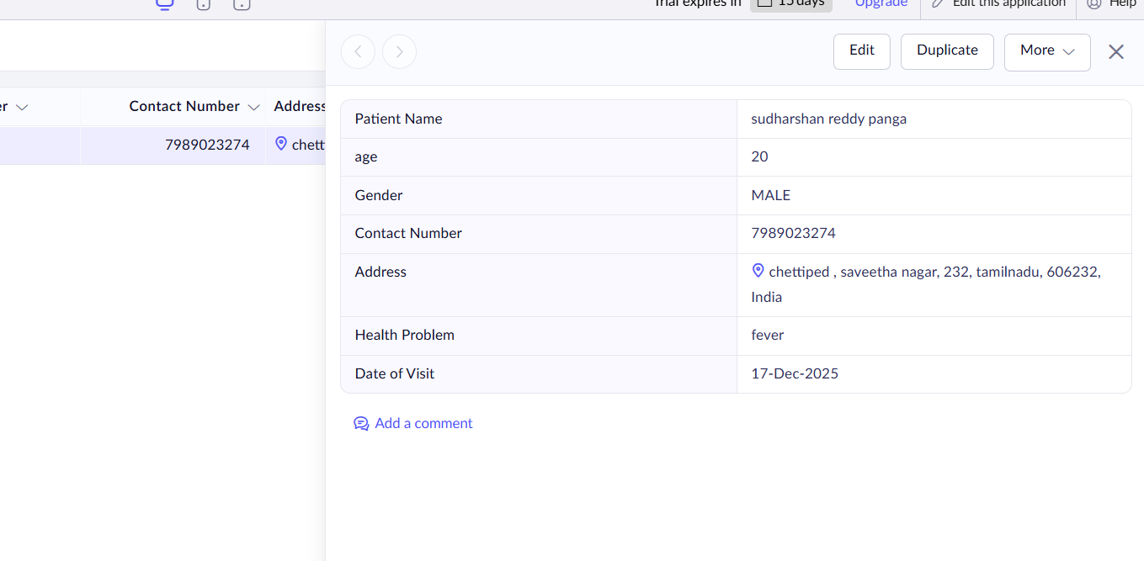
Figure 1: Patient Regestration Form

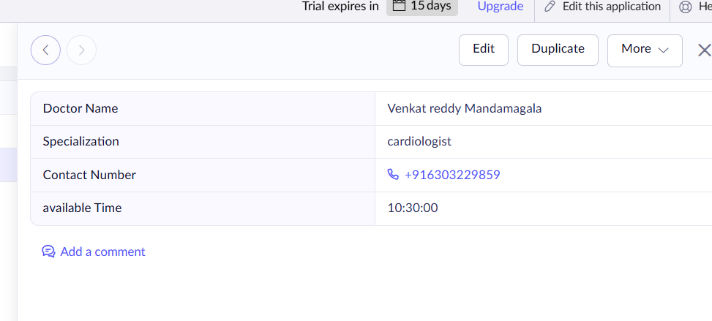
Figure 2: Doctor Details

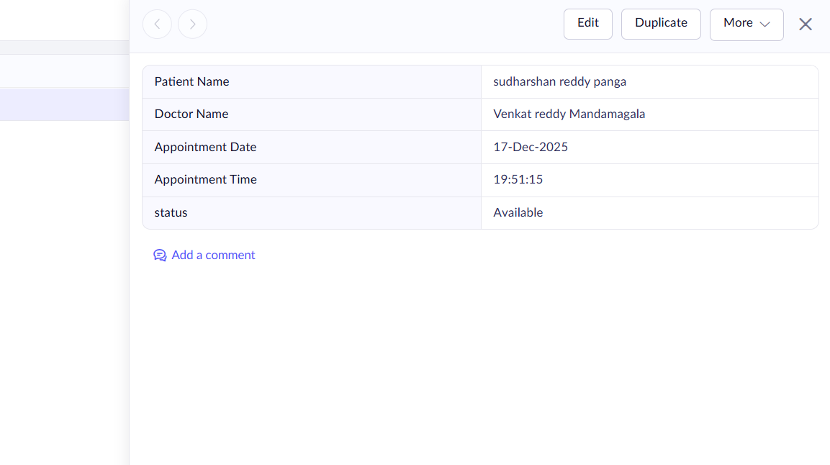

Figure 3: Appointment form
RESULTS
The cloud-based Hospital Management System was successfully designed, developed, and deployed using Zoho Creator as a Software as a Service (SaaS) application.

